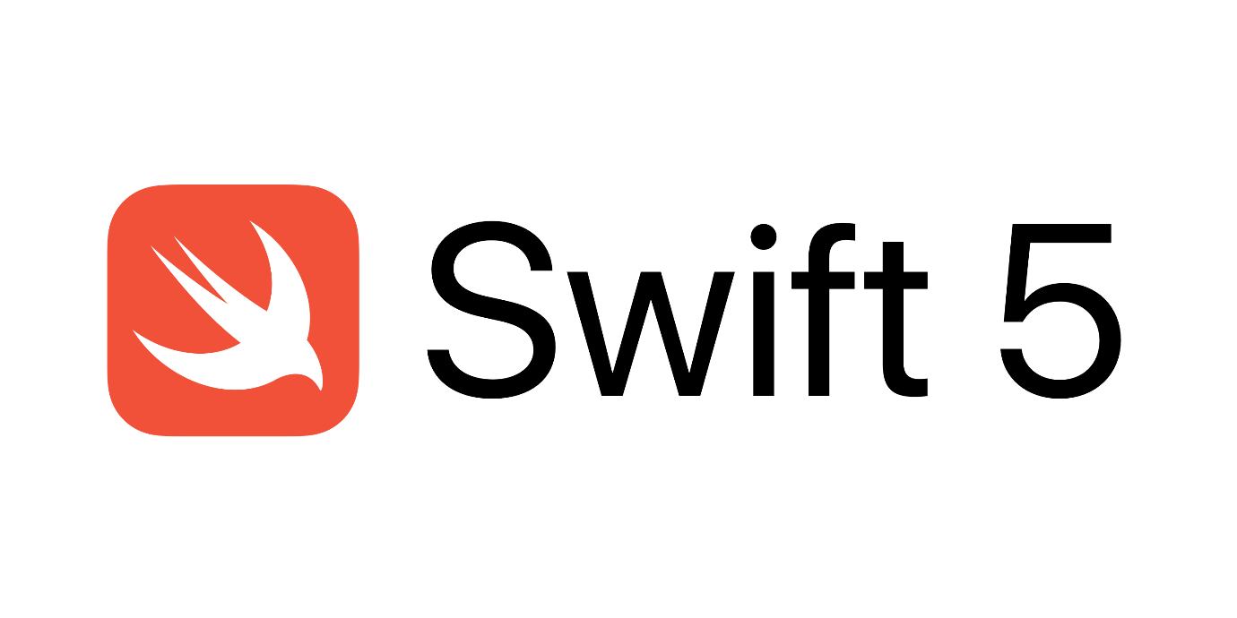

Swift Programs Starter

By Prateek Panwar

1. Installation of Swift, Xcode and Playground

Ans. **Installing Xcode:**

* 1. You can download Xcode from the apple website (https://developer.apple.com/xcode/) or you can search it on the Mac App Store. Note that this requires a 5GB download.
  2. You'll need to have an Apple ID before installing Xcode. If you don't have one, you'll be asked to create one.
  3. In the process of installing Xcode, you might be asked to update your Mac OS version.
  4. The OS update can be found in the Updates tab of the Mac App Store, we recommend to update it to the latest version.
  5. After the installation of the latest Mac OS, go to the Mac App Store and download Xcode or follow the above link.
  6. To check your installation, just try launching Xcode.

**Checking Xcode version:**

We need to update Xcode to latest versions to avoid problems. To check version:

You can check the version by launching Xcode. If the below screen doesn't show up after you launch Xcode, then click on Xcode on the top-left (in the menu bar) and click on "About Xcode".

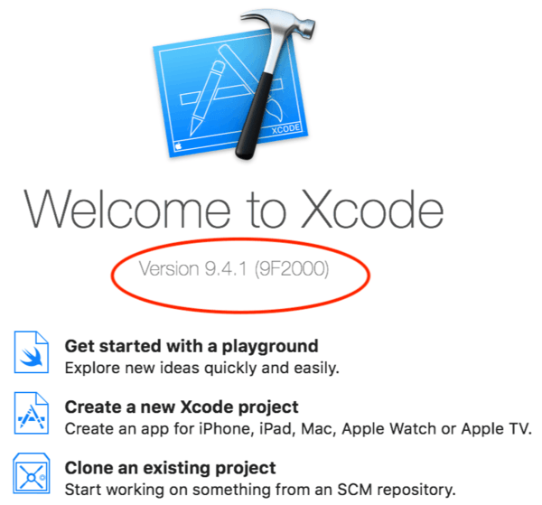

After this if it is verified that Xcode is latest version. Click on “Get started with a playground” and continue

1. Program to print Hello world (Using terminal and Xcode)

Ans.

import Swift

print("Hello, World!")

Output:

Hello, World!

3. Program to demonstrate variable and constant declaration in Swift.

Ans.

import Swift

let pi = 3.14

var radius = 2.0

print("Perimeter of Circle with radius 2 is: \(2*pi*radius)")

radius = 4

print("Perimeter of Circle with radius 4 is: \(2*pi*radius)")

Output:

Perimeter of Circle with radius 2 is: 12.56

Perimeter of Circle with radius 4 is: 25.12

4. Program to demonstrate different arithmetic operators in Swift.

Ans.

import Swift

var n1 = 3, n2 = 7

var i = 0

print("\(n1) + \(n2) = \(n1+n2)")

print("\(n1) - \(n2) = \(n1-n2)")

print("\(n1) * \(n2) = \(n1*n2)")

print("\(n1) / \(n2) = \(n1/n2)")

i = n1

i += n1

print("i = \(n1)++; i = \(i)")

i -= n1

print("i -= \(n1)--; i = \(i)")

Output:

3 + 7 = 10

3 - 7 = -4

3 * 7 = 21

3 / 7 = 0

i = 3++; i = 6

i -= 3--; i = 3

5.Program to demonstrate type Annotations and type Inference in Swift.

Ans.

import Swift

var text : String

text = "Happy Diwali"

print(text)

Output:

Happy Diwali

6.Program to demonstrate numeric type and other conversions in Swift.

Ans.

import Swift

var n1 = 3, n2 = 12.3

var ans : Double

ans = Double(n1) + Double(n2)

print(ans)

Output:

15.3

7. Program to demonstrate String Literals, Multiline string and special characters.

Ans.

import Swift

var name = "Krishna"

let singleLine = "Hello, I am \(name)"

let multiLine = """

My details are:

Age: 18

Hobbies: Cycling, Cricket

Height: 5 ft

Weight: 45 Kg

"""

print(name)

print(singleLine)

print(multiLine)

Output:

Krishna

Hello, I am Krishna

My details are:

Age: 18

Hobbies: Cycling, Cricket

Height: 5 ft

Weight: 45 Kg

8.Program to demonstrate String mutability , Empty String and String Interpolation.

Ans.

import Swift

let emptyString = ""

var fullName = "Krishna"

let lastName = "Kumar Kunnath"

var age = 18, height = 5.4

fullName += lastName

var text = "Hi, my full name is \(fullName)"

var text2 = "And my age is \(age) and my height is \(height)"

print(emptyString)

print(text)

print(text2)

Output:

Hi, my full name is KrishnaKumar Kunnath

And my age is 18 and my height is 5.4

9. Program to demonstrate Characters in Swift.

Ans.

import Swift

var char1 : [Character] = ["S","W","I","F","T"]

print(String(char1))

Output:

SWIFT

10. Program to demonstrate various String comparisons in Swift.

Ans.

import Swift

var char1 : [Character] = ["S","W","I","F","T"]

var emoji = "😊"

print("This is character: \(String(char1))")

print("This is emoji: \(emoji)")

Output:

This is character: SWIFT

This is emoji: 😊

11. Program to demonstrate For-In loop in Swift.

Ans.

import Swift

import Swift

print("Table of 2")

for i in 1...10

{

print("2 x \(i) = \(2*i)")

}

Output:

Table of 2

2 x 1 = 2

2 x 2 = 4

2 x 3 = 6

2 x 4 = 8

2 x 5 = 10

2 x 6 = 12

2 x 7 = 14

2 x 8 = 16

2 x 9 = 18

2 x 10 = 20

12. Program to demonstrate While loop in Swift.

Ans.

import Swift

var i=0

print("Memory Table")

while (i <= 8)

{

print("2 ^ \(i) = \(pow(2,i))")

i += 1

}

Output:

Memory Table

2 ^ 0 = 1

2 ^ 1 = 2

2 ^ 2 = 4

2 ^ 3 = 8

2 ^ 4 = 16

2 ^ 5 = 32

2 ^ 6 = 64

2 ^ 7 = 128

2 ^ 8 = 256

13.Program to demonstrate Repeat-While in Swift.

Ans.

import Swift

var i=1

print("Odd Numbers Upto 20")

repeat

{

print(i)

i += 2

}while(i<20)

Output:

Odd Numbers Upto 20

1

3

5

7

9

11

13

15

17

19

14.Program to demonstrate various control statements in Swift.

Ans.

import Swift

var n1 = 1, n2 = 1

print("Fibonacci Sequence")

for i in 1...20

{

print(n1)

(n1,n2) = (n1+n2,n1)

if n1>100

{

break

}

}

Output:

Fibonacci Sequence

1

2

3

5

8

13

21

34

55

89